**Sweet Couple: A Wedding Management System**



A Project submitted to the Department of Computer Science and Engineering,

Hajee Mohammad Danesh Science and Technology University

Course Title: Software Engineering

Course Code: CSE 305

|  |  |
| --- | --- |
| Submitted To,  Pankaj Bhowmik  Lecturer  Department of Computer Science and Engineering | Submitted By,  Kanij Fatema  Student ID: 2002023  Level 3, Semester I |

DEPARTMENT OF COMPUTER SCIENCE AND ENGINEERING

HAJEE MOHAMMAD DANESH SCIENCE AND TECHNOLOGY UNIVERSITY, DINAJPUR-5200, BANGLADESH

**Sweet Couple: A Wedding Management System**

The main goal of this project is to develop a software for wedding management system using different steps of Software Development Life Cycle (SDLC). First, I introduce the SDLC and then show the steps of SDLC to design the software.

**Introduction to SDLC**

The Software Development Life Cycle (SDLC) is a step-by-step process for making computer software. First, I figure out what the program needs to do and make a plan. Then, I design and build the program, checking to make sure it works right. After that, I share the program so people can use it. Finally, I keep an eye on it and fix any problems. SDLC helps us make good, reliable programs that do what people need them to do. It's like a roadmap for creating computer software, making sure everything is done properly from the start to the end. The following Fig. 1 shows the steps of SDLC to design a software.

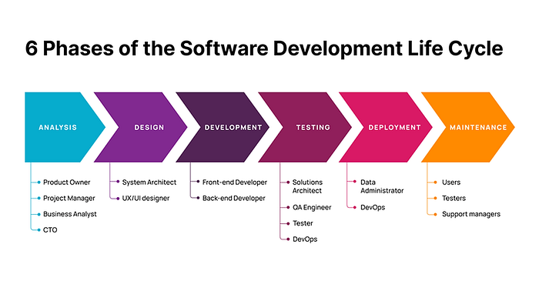

Fig 1. The Six phase of Software Development Life Cycle. [1]

In this project, I use SDLC step to design Wedding Management System (WMS).

The Wedding Management System (WMS) undergoes the Software Development Life Cycle (SDLC) to ensure a systematic and organized approach to its creation. Fig. 2 shows an overview of WMS. Here are the steps involved in WMS.

**1. Requirements Analysis**

**Objective:** Understand and document the needs and target of the WMS.

**Activities:**

* Conduct meetings with wedding planners, couples, and vendors to gather requirements.
* Identify key features such as guest management, budget tracking, vendor coordination, and scheduling.
* Define user roles and access permissions. It is for the security purpose of the WMS.
* Document functional and non-functional requirements from the given requirements to get the best features.

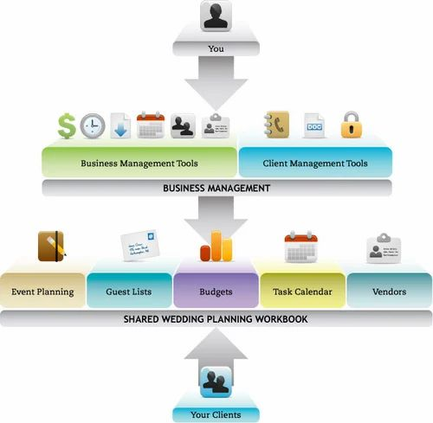

Fig 2. An overview of wedding management system. [2]

**2. Design**

**System Design:**

* Create a system architecture that outlines the structure and interaction of various modules (e.g., user interface, database, business logic) using ER, Use Case and Flow diagram.
* Define data flow and relationships between different components in WMS.

**Database Design:**

* Design the database schema to store information about weddings, guests, vendors, and other relevant data.
* Establish relationships between tables to maintain data integrity, data security.

**User Interface Design:**

* Develop graphical design and prototypes for the user interface.
* Design a user-friendly layout with features like event calendars, budget tracking tools, and contact lists.

**3. Development**

**Coding:**

* Implement the WMS functionalities according to the design specifications using programming languages.
* Use programming languages and frameworks suitable for the project.

**Database Implementation:**

* Create and configure the database based on the designed schema.
* Establish connections between the application and the database.

**Testing:**

* Conduct unit testing for individual modules to identify and fix any coding errors.

**4. Testing**

**Unit Testing:**

* Verify that each component works properly in the project.
* Address any issues identified during unit testing.

**Integration Testing:**

* Test the interaction between different modules to ensure they function together faultlessly.
* Detect and fix any integration issues.

**User Acceptance Testing (UAT):**

* Involve end-users to test the system in a simulated real-world environment.
* Gather feedback and make necessary adjustments.

**5. Deployment**

**Installation:**

* Deploy the WMS in the production environment.
* Ensure that all components are properly configured and connected.

**Training:**

* Provide training sessions for end-users, including wedding planners and administrators.
* Offer documentation for reference.

**6. Maintenance**

**Bug Fixes:**

* Address any issues or bugs reported by users’ post-deployment.
* Implement patches or updates as needed.

**Updates and Enhancements:**

* Incorporate new features or improvements based on user feedback or changing requirements.
* Ensure ongoing support and maintenance for the WMS.

Throughout the SDLC, communication with stakeholders is vital, ensuring that the WMS meets the unique needs of wedding planning while maintaining a reliable and user-friendly system. It is an incremental process, in every step we can modify and upgrade it.

**References**

1. https://productcoalition.com/a-comprehensive-guide-to-the-software-development-life-cycle-sdlc-15b7892e1d44
2. https://www.indiamart.com/proddetail/wedding-planner-software-10347579730.html